**OLABISI ONABANJO UNIVERSITY**

College of Engineering & Environmental Studies

Faculty of Engineering

Ibogun Campus.

**MECHANICAL ENGINEERING DEPARTMENT**

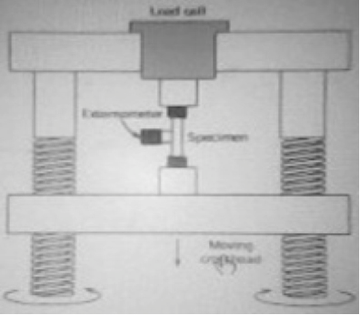

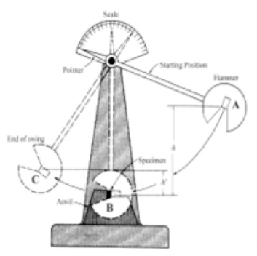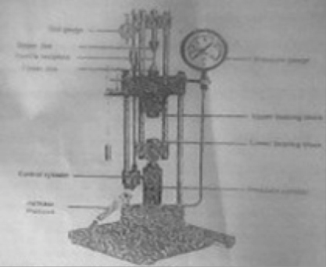**MATERIALS SCIENCE**

**AND ENGINEERING**

**LABORATORY MANUAL**

**200 LEVEL**

**NAMES…………………………………………………………………………………........ MATRIC. NO. :……………………………… LEVEL: ……………………………….. DEPT.: ……………………………………….. GROUP NO: ………………………… COURSE:…………………………………….. CODE: ………………………………... DATE:………………… SESSION:………… SIGNATURE: ………………….........**

**INTRODUCTION**

**1. General**

The need for laboratory work in Mechanical Engineering is very important. Laboratory's course work enables students to do experiments on the fundamental laws and principles encountered in the theoretical work; to study and use a wide variety of measuring instruments and equipment, to learn and to handle them with skill and to appreciate their limitations.

**2. Conducting the Experiments**

The experiment should be planned in advance by consulting necessary reference books in order to understand the principles behind the experiment. Before starting the experiment, the following steps should be taken:- i. Produce the Sketch for the experiment, ii. Produce the working diagram of the experiment, iii. Write down, in the form of a table, all the measurements you propose to make, and the calculation or formula to be used to obtain the results.

**3. Records**

A faithful record of all observations taken should be made in the space provided in the tables contained in the laboratory manual and should be duly signed by the supervisor. To obtain accurate results, repeat the experiment using different methods where possible. The account of the experiment should be written in a practical notebook, which has graph paper on alternate pages. If the notebook is not ruled for graphical work, a sheet of graph paper can be interleaved when necessary between the double pages of the record. The report should be in a suitable format as follows:- i. Title, ii. Objectives, iii. Equipment/Apparatus/Materials,

iv. Theory/Diagram, v. Method/Procedures, vi. Measurements/Results, vii. Calculations viii. Graphs, ix. Results or Conclusion, x. References

**4. Attendance**

All students who registered for the laboratory courses must attend classes when required. There is a system of taking attendance register and this is considered when grading your laboratory work/report.

**5.0 Reference Tables**

**5.1 Multiple and Sub-multiples units and their abbreviations**

T = Tera = 1012, f = femto = 10-15

G = Giga = 109 , p = pico = 10-12

M = Mega = 106 , n = nano = 10-9

K = Kilo = 103 , u = Micro = 10-6

M = Milli = 10-3

1 MPa (MegaPascal) = 1 × 106 N/m2 = 1 N/mm2

1 GPa (GigaPascal) = 1 × 109 N/m2 = 1 kN/mm2

**5.2 Common Abbreviations**:

mA = milliAmeter, d = diameter, t = thickness, s = second, σ = stress, ε = strain

*l* = Original length of the body, Δ*l* = Change in length of the body, and

*E* = Young's modulus or modulus of elasticity*,* τ = Shear stress,

ϕ = Shear strain, *C* = Shear modulus (Modulus of rigidity).

**6. Graphs**

Whenever possible, the result of an experiment should be presented in graphical form. In plotting the results, the dependent variable should be plotted as ordinates on the y- axis, and the independent variable as abscissas on the x – axis. The scale used should a convenient one for arithmetical work, and should be sufficiently extensive for the graph to occupy a wide sweep of the space available. On the other hand, too large a scale will tend to accentuate the errors of observation and obscure the relationship between the two quantities.

**7.0 General Laboratory Safety**

Safety is one of the major elements of good laboratory management, but it is perhaps the most neglected. It should be understood that any use of electricity inherently involves some degree of safety hazard. Whilst every effort is made by responsible manufacturers to reduce the hazard, it is still rest with the users to play his part in ensuring his own safety.

The major-causes of laboratory accidents can be categorized into two:

Human cause which includes: i. Carelessness, ii. Ignorance, iii. Wrong attitudes, iv.Negligence.

**Contributory causes:**

I. Physical condition of students,

ii. Unsatisfactory or inappropriate equipment, iii. Diverted attention,

iv. Congested work stand, or inappropriate attire

**The best ways to achieve safety in the use of electrical equipment includes:**

i. Taking no chances, nor short cuts, in safety procedures.

**7.1 Safety**

This manual contains a number of guidelines which can help you perform your research works more safely and maintain better order and safety in our laboratories.

Each student is expected to read this manual thoroughly and act in agreement with the guidelines. This manual should also be kept available for future reference.

There are two golden rules in developing a safe and productive environment:

(1) Whenever you use a lab, it is your responsibility to see that unsafe conditions are corrected immediately; and (2) Always leave a laboratory in better condition than you found it.

If we all take this level of personal responsibility, our facilities can only improve.

We hope to periodically update and revise this manual to make it more useful and more effective. We hope keep you stay safe and productive.

Safety requires a careful and deliberate approach to each test before undertaking any experiment; the student must understand what to do and how to do it.

**7.2 Safety rules:**

The following important safety rules should be observed at all times:

i. Do not clown or gossip in the laboratories, ii. Do not sit on the work bench,

iii. Extraneous items should be removed from the table,

iv. Attention should be paid for clamping the job, tool, tool holders or supporting cutters.

v. Ask for instructions before the use of any item of test equipment for the first, time, even if you think you know how to use it. A little knowledge can be dangerous.

vi. Do not use any ring and wrist watch during practical periods. vii. Do not use any necklace or chain during practical periods. viii. Your hand nails must be dressed and properly maintained. ix. Avoid loose clothes in the laboratory and workshop.

x. Always wear safety goggle where necessary. xi. Do not eat nor drink during practical periods. xii. Ask when you do not know.

**MANDATORY PERSONAL PROTECTIVE WEARS FOR LABORATORY AND WORKSHOP**

i. White long sleeve laboratory coat for laboratory practical. ii. Blue long sleeve overall for workshop practical.

iii. Safety boot / hard sole leather shoe.

**MATERIAL SCIENCE AND ENGINEERING**

**Table of Contents**

|  |  |  |
| --- | --- | --- |
| Introduction | - | - 1 |
| Experiment 1 | - Physical and Mechanical Properties of Materials | - 5 |
| Experiment 2 | - Rockwell Hardness test | - 10 |
| Experiment 3 | - Brinell hardness test | - 12 |
| Experiment 4 | - Position of specimen for Izod test | - 14 |
| Experiment 5 | - Charpy Test | - 16 |

**EXPERIMENT 1**

**TITLE: PHYSICAL AND MECHANICAL PROPERTIES OF MATERIALS**

**AIM**: To determine: (i) the physical properties of the materials (ii) elastic limit

(iii) yield point (iv) percentage elongation (v) reduction of area

**APPARATUS:** Tensile Testing Machine, Vernier Caliper, Micrometer screw gauge, Pressure gauge, Test pieces (mild steel, brass, copper & aluminium)

**INTRODUCTION:**

The mechanical property of material is the ability of the material to resist mechanical forces and loads which are ascertained by performing carefully designed laboratory experiments that replicate as nearly as possible the service conditions. Mechanical properties include strength, elasticity, plasticity, ductility, stiffness, malleability, brittleness, hardness, resilience, toughness, creep, fatigue …

Mechanical testing of engineering materials is carried out for a number of reasons: to simulate the service conditions of a material, to predict its *service performance,* to provide engineering *design data* and to check whether the material meets the specification.

The mechanical behaviour of a material reflects the relationship between its response and deformation to an applied load or force. It is one of the important criteria in design, fabrication and material selection for engineering application. Important mechanical properties are strength, hardness, ductility, and stiffness.

Property defines the quality of the specific characteristic of a metal.

The physical properties of materials includes density, hardness, elastic modulus, melting point, damping capacity, heat capacity, thermal conduction, thermal expansion, electrical conduction and colour.

Testing and inspection are very important in engineering activities which must be done at various stages in engineering process, design, assembly and components/machines production to meet a specific requirement.

Two major group of test are Destructive and Non-destructive to establish the properties of materials and to determine the integrity of the materials.

**Destructive Test**- The test specimen is tested until it's structural failed completely in order to determine its mechanical properties and characteristic. The test can be performed by tensile test, compression test, impact test, Hardness test, creep test, fatigue test.

Destructive: Tensile test is used for mechanical test of metals. It gives accurate information of the properties of the materials. A rectangular/flat or circular test-piece is tighten/secured at both ends and pulled till the test-piece breaks. It would prove the material elasticity, the elastic limit and its breaking point.

**Non-destructive**: The test material maintained the same mechanical properties before and after the test, the test piece is still serviceable after subjected to loading conditions. Hardness test is used to determine the resistance to deformation. The hardness of the material can be measured from the depth, size and shape of the indentation.

The three methods used in hardness test include:

Brinell test- a hardened ball/diamond point is pressed into the surface of the materials for a given period at a given load/force.

Rockwell test- The test is completed using a small ball or cone. The resultant test does not damage the material.

**THEORY**

**The Tensile test**

The tensile test is widely used for measuring the stiffness, strength and ductility of a material. The testing machine subjects the test-piece to an axial *elongation* and the resultant *load* on the specimen is measured. Depending on the nature of the product being tested, the specimen may be round or rectangular in cross-section, with the region between the grips usually being of reduced cross–section. The *gauge length* is marked in the region.

Stress = Load/Cross-sectional area

Strain = Extension of gauge length/Original gauge length,

Test-pieces: To complete a tensile test, a test piece in the figure below is used Lo – Original length, Do – Original Diameter

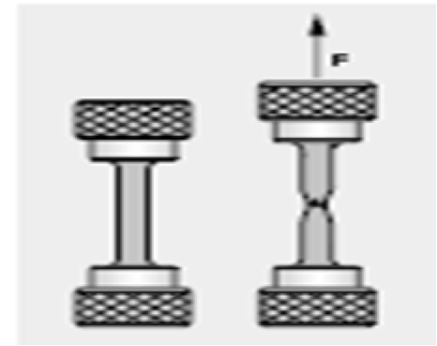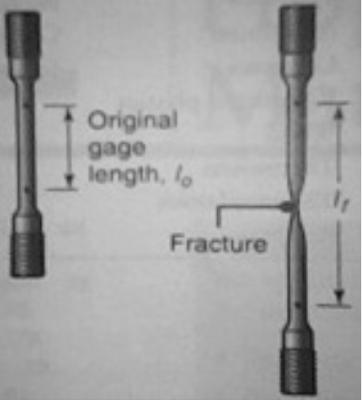

Figure 1.1: Test piece with a circular cross-section



Figure 1:2: Specimen after elongation

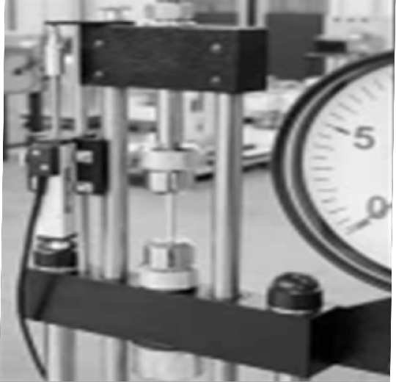

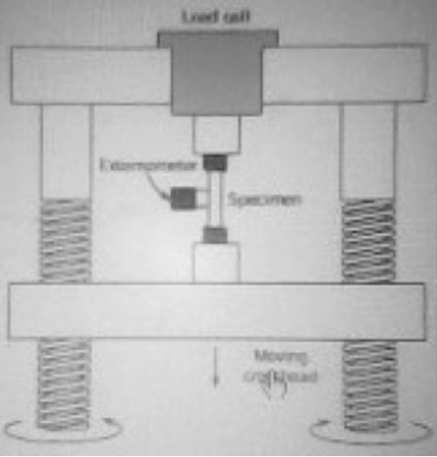Figure 1.3: Tensile Testing Machine Figure 1.4: Schematic representation of the

Tensile testing machine

**PROCEDURE**

The threaded ends of the circular cross-sectional test piece are screwed into the jaws on the tensile test machine. The rod is smoothly tapered out to the threaded part, on the parallel centre part are two marks, which are at a distance apart of five times the diameter: Lo – 5Do where Lo is Original length, Do is Original Diameter. After the test, the marks are to judge the plasticity of the material.

TEST READINGS – A test piece is screwed into the jaws and the jaw is slowly pulled apart. The force is increased and test piece stretched before it's finally breaks. The quantities to be measured during the test are the tensile strength F and extension ΔL of the test quantities to calculate the tensile strength δ(N/mm2), F/A, the ratio of force per unit area and strain ϵ which is a ratio of change in length

/original length.

Hook's Law is the relationship between the stress and the strain. E =δ/ϵ (E is modulus of elasticity)

Table 1.1: Value of materials properties

|  |  |
| --- | --- |
| Materials | Modulus of elasticity E (N/mm2) |
| Iron | 200 |
| Copper | 125 |
| Brass | 100 |
| Aluminium | 72 |

**TEST ON THE MATERIALS** (Cast iron/mild Steel, Brass and Aluminium). i. Measure the diameter of the test pieces on the grooved surface.

ii. Measure the distance of the test pieces (5mm away on both sides from the centre and mark the point with pencil).

iii. Mount the dial gauge on the small rod beside the machine jaws.

iv. Screw in the test piece into the jaws.

v. Tension the test piece by winding up the knob on the top of the hydraulic cylinder. vi. Set both pressure gauge and dial gauge to zero.

vii. Slowly and carefully load the machine by turning the pressure handle clockwise.

viii. Read off the pressure gauge at interval of 1 kN and the corresponding dial gauge accordingly. ix. Continue loading until then test piece breaks and note the breaking point.

x. Remove the two halves of the test piece, put them together on the bench and re-measure both the final diameter and final length.

xi. Repeat the same procedure for the other materials specimen provided.

**Table of Results for the materials, (Mild Steel, Cast Iron, Brass, Copper or Aluminium)**

Original Length = …………. mm Final Length = ………….. mm Original Diameter = ...………… mm Final Diameter =....………… mm

Table 1.2: Table of Results

|  |  |  |  |  |  |
| --- | --- | --- | --- | --- | --- |
| FORCES (kN) | FINAL LENGTH (mm) | ORIGINAL LENGTH (mm) | ELONGATION (mm) | STRESS | STRAIN |
| 1 |  |  |  |  |  |
| 2 |  |  |  |  |  |
| 3 |  |  |  |  |  |
| 4 |  |  |  |  |  |
| 5 |  |  |  |  |  |
| 6 |  |  |  |  |  |

Note: The table of results is for each material

EXERCISES:

(a) Plot the graph of;

(i) Force against Elongation, (ii) Stress against Strain

(b) Determine from the graph:

(i) Maximum force of the material

(ii) The tensile strength (Ultimate tensile stress), (iii) The fracture stress,

(iv) Percentage Elongation,

(v) Percentage Reduction in area

(c) Compare the curves on the graph and briefly explain your observations on the difference in the tested material properties.

(d) A piece of copper originally 305 mm long is pulled in tension with a stress of 276 MPa. If the deformation is entirely elastic, what will be the resultant elongation?

(e) A tensile stress is to be applied along the long axis of a cylindrical brass rod that has a diameter of 10 mm. Determine the magnitude of the load required to produce a 2.5 x 103mm change in diameter if the deformation is entirely elastic.

(f) Define the following terms Resilience, toughness, Ductility, yield stress. (g) State the major function of Extensometer.

(h) State the necessary precautions observed during the experiment.

**EXPERIMENT 2**

**TITLE: ROCKWELL HARDNESS TEST**

**Objective:** To determine the hardness the Hardness of the given Specimen using Rockwell hardness test.

**Equipment and Materials:** Rockwell hardness testing machine, Black diamond cone indenter, Hard steel specimen.

**Theory**

The test is an indentation test used for smaller specimens and harder materials.

The test forced indenter into the surface of a test piece in two operations, measuring the permanent increase in depth of an indentation from the depth increased to the depth reached under a datum load due to an additional load.

Measurement of indentation is made after removing the additional load. Indenter used is the cone having an angle of 120 degrees made of black diamond.

NOTE: Thickness of the specimen should not be less than 8 times the depth of indentation to avoid the deformation to be extended to the opposite surface of a specimen.

Indentation should not be made nearer to the edge of a specimen to avoid unnecessary concentration of stresses. In such case distance from the edge to the centre of indentation should be greater than 2.5 times diameter of indentation.

Rapid rate of applying load should be avoided. Load applied on the ball may rise a little because of its sudden action. Also rapidly applied load will restrict plastic flow of a material, which produces

effect on size of indentation.

**DIAGRAM**

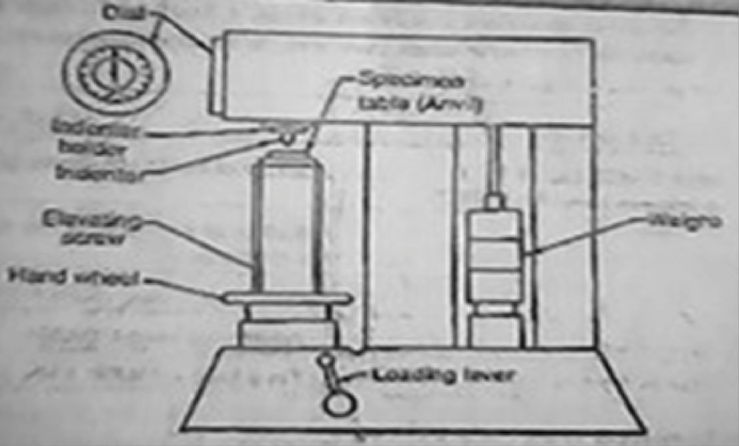

Figure 2.1: Rockwell hardness test equipment

**Procedure**

I. Examine hardness testing machine in Figure 2.1.

ii. Place the specimen on platform of a machine. Using the elevating screw raise the platform and bring the specimen just in contact with the ball. Apply an initial load until the small pointer shows red mark.

iii. Release the operating valve to apply additional load. Immediately after the additional load applied, bring back operating valve to its position.

iv Read the position of the pointer on the scale, which gives the hardness number.

iv. Repeat the procedure five times on the specimen selecting different points for indentation.

**RESULTS AND CALCULATION**

i. Take five values of indentation of each specimen and obtain the average. ii. Observe and record the hardness number from the dial of a machine.

iii. Compare Brinell and Rockwell hardness tests obtained. iv. Determine the hardness of the given specimen

**EXPERIMENT 3**

**TITLE: BRINELL HARDNESS TEST**

**Aim:** To determine the hardness of the given specimen using Brinell hardness test.

**Equipment and Materials:** Brinell Hardness testing machine, Ball indenter, Aluminum specimen.

**Theory:**

Hardness of a material is defined as Resistance to the permanent indentation under static and dynamic load. When a material is required to use under direct static or dynamic loads, only indentation hardness test will be useful to find out resistance to indentation.

In Brinell hardness test, a steel ball of diameter (D) is forced under a load (F) on to a surface of test specimen. Mean diameter (d) of indentation is measured after the removal of the load (F).

NOTE: Thickness of the specimen should not be less than 8 times the depth of indentation to avoid the deformation to be extended to the opposite surface of a specimen. Indentation should not be made nearer to the edge of a specimen to avoid unnecessary concentration of stresses. In such case distance from the edge to the centre of indentation should be greater than 2.5 times diameter of indentation.

Rapid rate of applying load should be avoided. Load applied on the ball may rise a little because of its sudden action. Also rapidly applied load will restrict plastic flow of a material, which produces effect on size of indentation. Surface of the specimen is well polished, free from oxide scale and any foreign material.

**DIAGRAM**

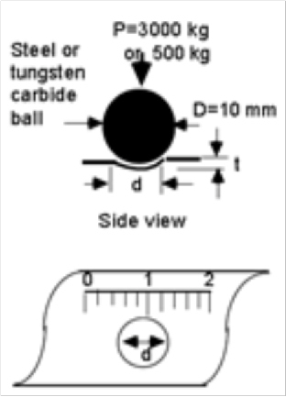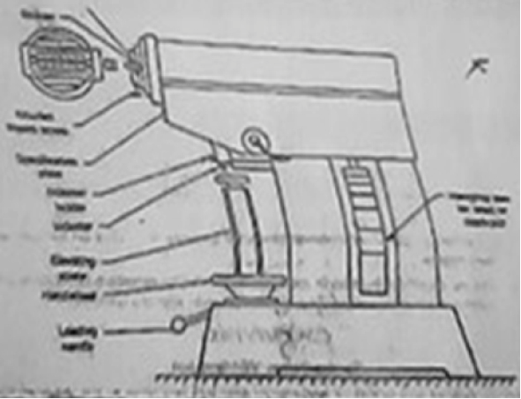

Figure 3.1: Brinell hardness equipment Figure 3.1: Brinell hardness test

**Procedure**

I. Select the load to be applied for hardness test according to the expected hardness of the material.

ii. Keep the test load equal to 30 times the square of the diameter of the ball (diameter in mm) F=30D2

(Where ball diameter, generally taken as 10 mm).

iii. Apply the load for a minimum of 15 seconds to 30 seconds. [ time for ferrous metals to be tested will be 15 seconds and softer metal will be 30 seconds].

iv. Remove the load and measure the diameter of indentation nearest to 0.02 mm using microscope

(projected image), magnifying lens (glass).

Guidelines on hardness range for standard loads are shown below in Table 3.1.

**Table 3.1: Specification of materials and load**

|  |  |  |
| --- | --- | --- |
| Ball diameter | Load (kg) | Range of Brinell hardness |
| 10 | 3000 | 96 to 600 |
| 10 | 1500 | 48 to 300 |
| 10 | 500 | 16 to 100 |

**Brinell Hardness number:**

2F/(πD[D- (D2-d2)]

where D is the diameter of ball indenter and d is the diameter of indentation.

Hardness numbers normally obtained under 3000 kg and 10 mm diameter ball used for different materials are stated below.

Table 3.2: Material Hardness Specification

|  |  |
| --- | --- |
| MATERIALS | HARDNESS NUMBERS |
| Medium carbon steel | 100 to 500 |
| Structural Steel | 130 to 160 |
| Hard Steel | 800 to 900 |

Note: Brinell test is not recommended for the materials having HB over 630.

It is important to observe and know the ball size and load with the hardness test when standard size of ball and load are not used. Because indentation done by different size of ball and load on different materials are not geometrically similar due to the different in size. When load is applied, ball also undergoes deformation and the material response to the load is not always the same

**RESULTS AND CALCULATION**

i. Take average of five values of indentation of each specimen. Obtain the hardness number from equation.

ii. Compare Brinell and Rockwell hardness tests obtained. iii. Calculate Brinell hardness number (HB) of the specimen.

**TITLE: IZOD TEST**

**Equipment and Material:** Impact testing machine, 2. Specimen and v notch (Size of the specimen is

10mm X 10mm X 75mm)

**Diagram**

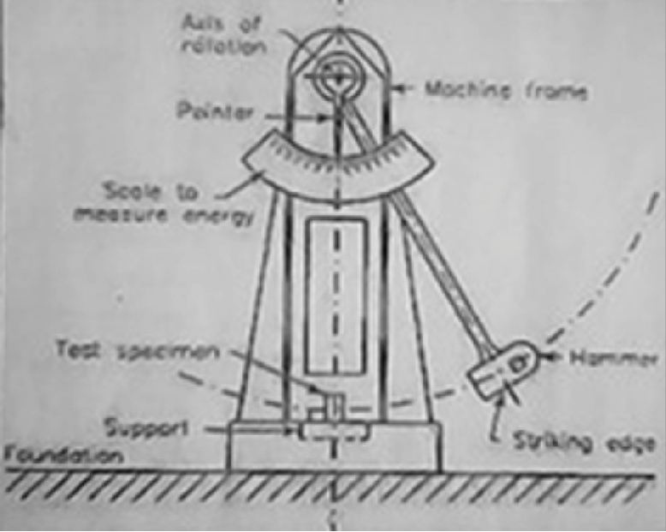

Figure 4.1: Izod Impact testing equipment

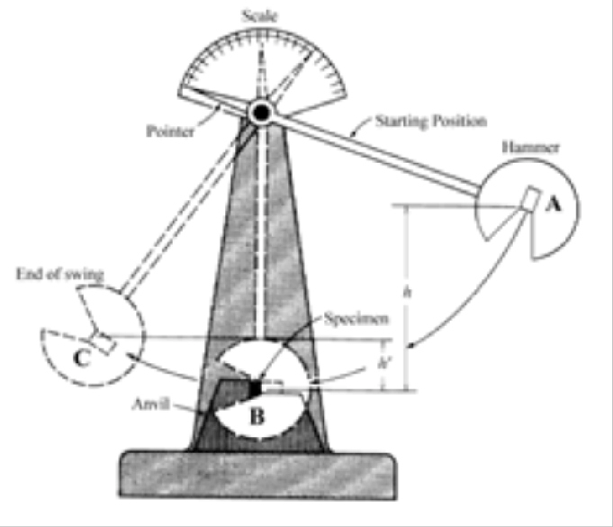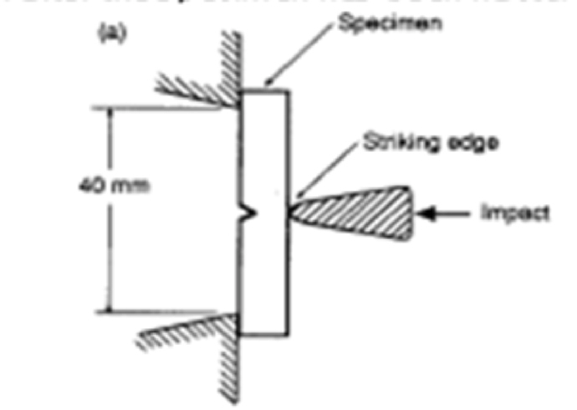

Figure 4.2: Schematic impact testing that employs pendulum principle

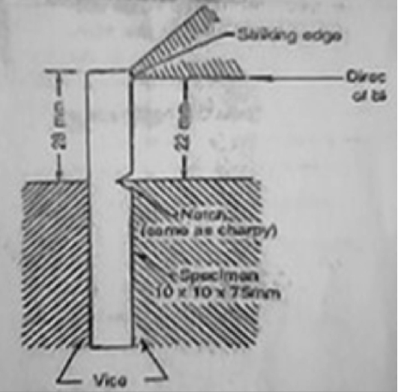

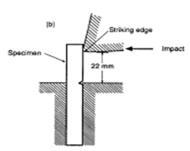Figure 4.3: Position of specimen for Izod test

**Procedure:**

1. Specimen is clamped to act as vertical cantilever with the notch on tension side.

Direction of blow of hammer is shown in fig….. .

2. Measure the dimensions of a specimen and that of the notch.

3. Raise the hammer of the machine and note down initial reading from the dial pointer, which indicate the energy to be used to fracture the specimen.

4. Place the test specimen at the centre with respect to hammer and check the position of notch.

5. Release the hammer and note the final reading to determine the actual energy required to fracture the Specimen.

6. Repeat the test for other materials specimens.

7. Compute the energy of rupture of each specimen.

**Results and Calculation**

Record the Initial and final reading of the dial in tabular form. Determine the Strain energy of the given specimen.

**TITLE: CHARPY TEST**

**Equipment and Material:** Impact testing machine, U notch cut across the middle of one face.

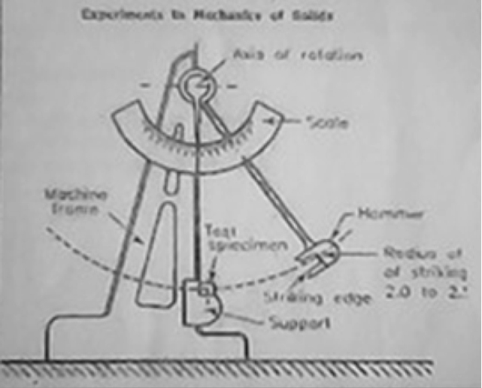**Diagram**

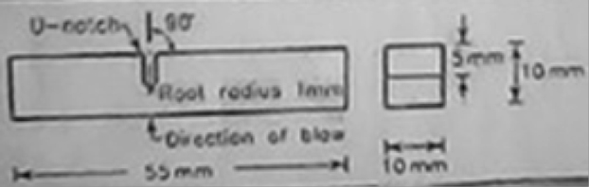

**Figure 5.2: Specimen for Charpy test**

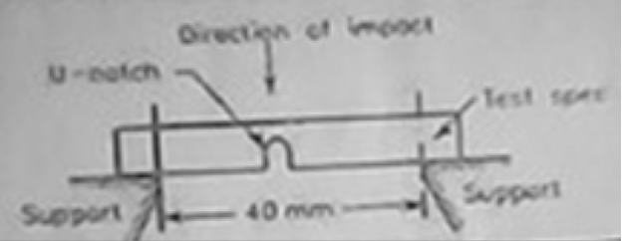

**Figure 5.1: Charpy impact testing equipment**

**Figure 5.3: Mounting of the Specimen**

**Procedure:**

**Mounting of specimen**

1. Specimen is mounted on a beam supported at each end and the hammer is allowed to hit the specimen at the opposite face behind the notch.

2. Measure the dimensions of a specimen and of the notch.

3. Raise the hammer and note down initial reading from the dial indicator, which will be energy to be used to fracture the specimen.

4. Placed the specimen for test at the centre with respect the hammer and check the position of notch.

5. Release the hammer and note the final reading to give the actual energy required to fracture the specimen.

6. Repeat the test for other materials.

**Results and Calculation**

1. Record the initial and final readings of the dial in tabular form.

2. Compute the energy of rupture of each specimen.

3. Determine the strain energy of given specimen.

**Title: .........................................**

**Scale:**

x: ......................................

y: ......................................



**Title: .........................................**

**Scale:**

x: ......................................

y: ......................................



**Title: .........................................**

**Scale:**

x: ......................................

y: ......................................

